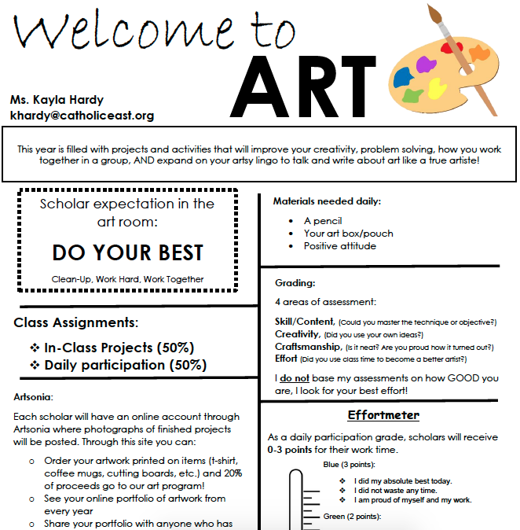
Do Now’s (Daily Participation):
CRAFTING!
as participation. If a scholar is absent or loses his/her packet, he/she must schedule a time before the end of the semester to make up these exercises. They can then be made up for full credit.
Mrs. Appleby
sappleby@bigfork.k12.mt.us
- Pencil
- Class Folder
- Any craft materials you can donate
Daily Participation:
Participation in crafting is paramount. If you miss a day or days of class, you cannot just skip crafting. You must schedule makeup time at lunch to make up your missing time and receive participation credit for the days you have missed. All missed time can then be made up for full credit.

Research/Planning Assignments:

These are a collection of assignments where scholars will have class time to research their own crafting project ideas. Students have to completely plan out 10 craft possibilities of their own choosing. These crafting plans must include supply list costs, completion time and step by step instructions. Then students will be able to choose one of their own crafts to complete for their Final Assignment. This final assignment will be the largest part of the Trimester Project grades. These assignments are open to interpretation, require pre-planning, and are meant to encourage a homework and family participation for completion.

Crafting class might sound weird, but it was born from years of students begging me to teach a coloring class. So I took their ideas and desires and came up with crafting! Crafting is a trimester long elective class, and while it will be a relaxing awesome period during your school day, we will work on neatness, creativity, ingenuity and most of all, fine motor skills. I believe this class will lead to improved neatness and accountability in other classes, and in turn, better grades overall!

