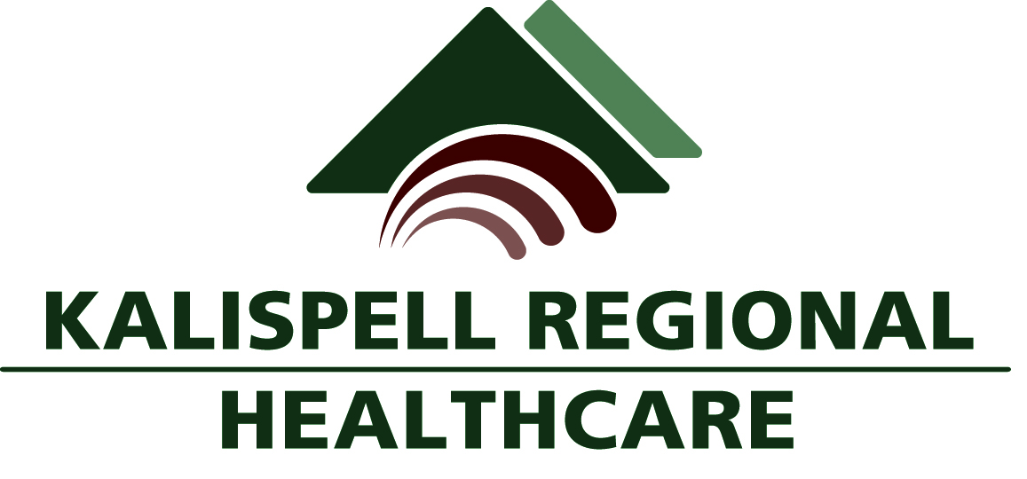

Comprehensive School Community Treatment (CSCT)
Kalispell Regional Behavioral Health (KRBH) provides services to qualifying youth in the school and community environment through the CSCT program.

In CSCT, each participating School District, through an agreement with a Licensed Mental Health Center, can offer intensive level mental health services to qualifying students throughout the school day. Services offered include individual, group, family therapy, and daily mental health support as needed. The CSCT program is administered statewide by the State of Montana.

STAFF
Kalispell Regional Behavioral Health (KRBH) provides a Licensed Therapist and a Mental Health Worker at each school site to implement the CSCT program. Our Therapists are Licensed Clinical Social Workers and Licensed Clinical Professional Counselors. Our Mental Health Workers have degrees in Mental Health-related fields. A full-time Clinical Supervisor oversees the program with support from the Behavioral Health Administrator and the Behavioral Health Medical Director.

PROGRAM
Students work with CSCT staff during the day in formal sessions and in the school environment as a whole, i.e. recess, class time, lunch, and special events. Crisis response for CSCT students is available during the day on-site. A 24-hour crisis care line is accessible after hours and on weekends and holidays. CSCT staff provide care coordination with other agencies and community resources to assist the student and family throughout the treatment process. CSCT staff play an active role in assisting children and adolescents with positive peer interactions in daily school activities.

REFERRALS
Students are referred to the CSCT program by school staff, family members, and other agencies in the community. Students are admitted to the program after a clinical evaluation shows the student meets requirements for Seriously Emotionally Disturbed (SED). A parent/guardian signed Consent for Treatment in the CSCT program is required. A parent/guardian signed Release of Information is required to enable CSCT staff/school staff to communicate.
ASSESSMENT/INTAKE
The CSCT Therapist schedules an appointment to meet with the parent/guardian to obtain the student’s mental health history and determine the student’s clinical eligibility to receive CSCT services. Family involvement is critical to the student’s success in the CSCT program.

TREATMENT TEAM
CSCT staff set up a treatment team that includes the student, family, any applicable school staff, other involved agency staff, and the CSCT team. A Master Treatment Plan (MTP) is developed to outline the team’s goals and objectives to be used with the student on a daily basis. MTP’s are reviewed and updated every 90 days or sooner to reflect changes in the student’s functioning or to make changes in the Treatment Plan. Treatment Team members have daily contact with the student and contact the family as much as possible. Progress is documented in daily charting by CSCT staff.

ADVOCACY
Through Care Coordination, CSCT staff act as advocates to help families obtain the necessary services and support. CSCT staff can make referrals for other community services, more intensive levels of care, provide access to psychiatric/physician evaluation and act as a liaison between the school and the family. We believe in quality of care and will do our best to make that happen for each youth in our program and their family.

DISCHARGE
CSCT is a Treatment Program. Under the care of CSCT staff and the Treatment Team, students often show progress by meeting treatment goals and objectives successfully in school, home, and community settings. The Treatment Team may recommend the student be discharged from the program after a period of measured success.

FEE FOR SERVICES
State of Montana CSCT rules require all participants be charged for services. Insurance programs, such as Montana Medicaid, pay for CSCT services. Certain other private insurances may also pay for CSCT services. CSCT staff can assist families in helping them apply for insurance programs. Sliding fee or private pay situations are negotiated on a case-by-case basis.

PROGRAM LOCATIONS
Kalispell Regional Behavioral Health offers CSCT program services in the following School Districts: Kalispell Public Schools, Columbia Falls Public Schools, Somers-Lakeside Public Schools, Bigfork Public Schools, and Whitefish Public Schools.

CONTACTS
Please call 756-3950 for information or visit www.kalispellregional.org, click on Behavioral Health Services, and select School-Based Services.

