The Fork –Tentative Menu
September 2017

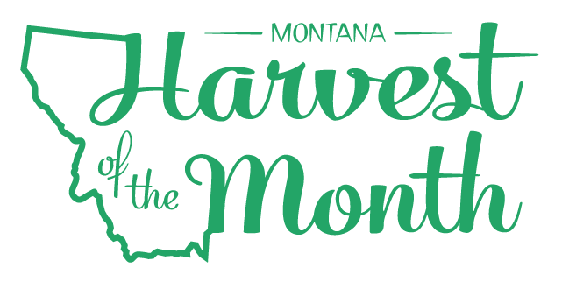
Monday | Tuesday | Wednesday | Thursday | Friday
1
NO SCHOOL
4  Labor Day | 5  Deli Turkey Sandwich | 7  Pizza  Fruit | 8  Chicken Nuggets | 9  Cheeseburger
12  Spaghetti | 13  Mini Pancakes  Vanilla Yogurt  Blueberries | 14  Pizza | 15  Beef Taco | 16  Baked Chicken Sandwich
19  Macaroni Beef Bake | 20  Egg Roll  Seasoned Rice | 21  Pizza | 22  Nachos | 23  Tuna Sandwich
26  Tomato Soup/Toasted Cheese | 27  Mini Pancakes | 28  Pizza | 29  Chicken Fajita | 30  Chicken Corn Dog
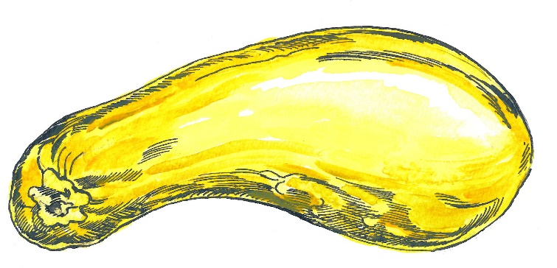
Grades 6-8 Choices
M Pizza or Deli Sandwich
T Cheeseburger or Deli SW
W Chicken Sandwich or Deli SW
TH Burrito Bowl or Deli SW
F Pizza or Deli Sandwich
Grades 9-12 Choices
M Pizza, Deli Sandwich, Rice Bowl
T Chicken Sandwich, Deli Sandwich,
W Rice Bowl
TH Pizza
F Chicken Sandwich

All Lunches served with our awesome Salad Bar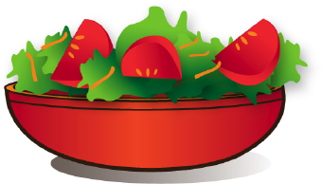
Fruit and 8oz Milk

Contact Info:

837-7409
Summer Squash are this month’s Harvest of the Month. Did you know…
- Summer squash are in the vegetable food group.
- Zucchini is the most common variety of summer squash. Summer squash are harvested in the summer and have thin skins and soft flesh. Winter squash, on the other hand, are harvested later in the season and have thick rinds.
- Summer squash are members of the Cucurbitaceae (Cucurbit) family, which includes melons, pumpkins, cucumbers, and gourds.
To learn more about Montana Harvest of the Month visit: www.montana.edu/mtharvestofthemonth

